**Decoupling Dropdowns From charts in Topaz**

1. Adding Common button

**cshtml**

@section ExtraSelectionBoxes

{

}



Controller.js

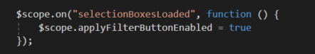

1. Button handler function in Controller.js

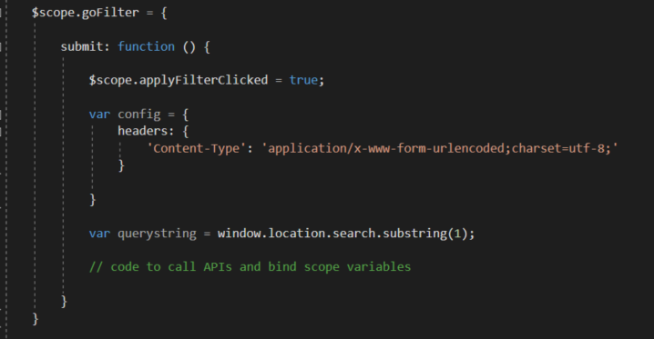

1. Compare old binding code from new approach

OLD->



NEW->



Example 1

OLD🡪

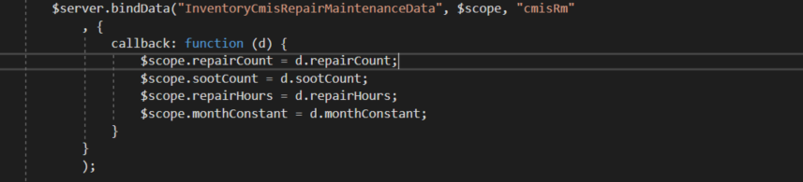

NEW->

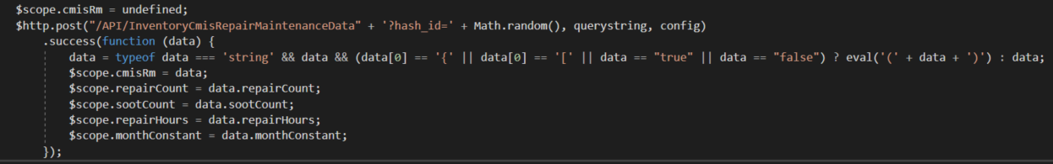

Example 2

OLD->

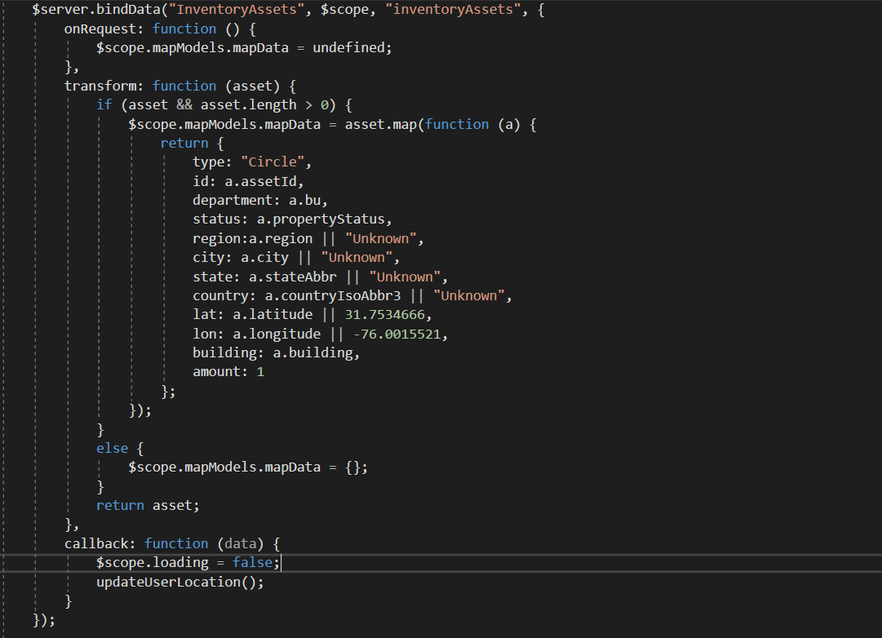

NEW->

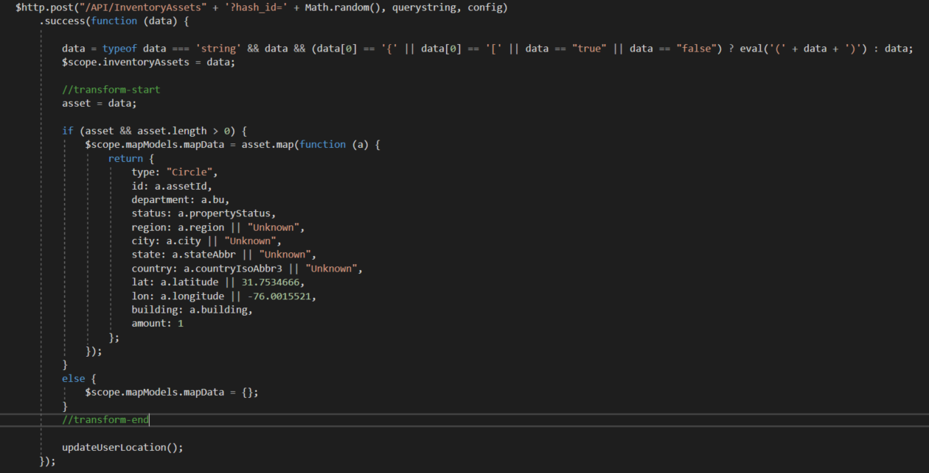

1. Handling multiple controllers

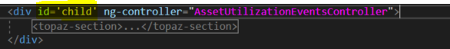

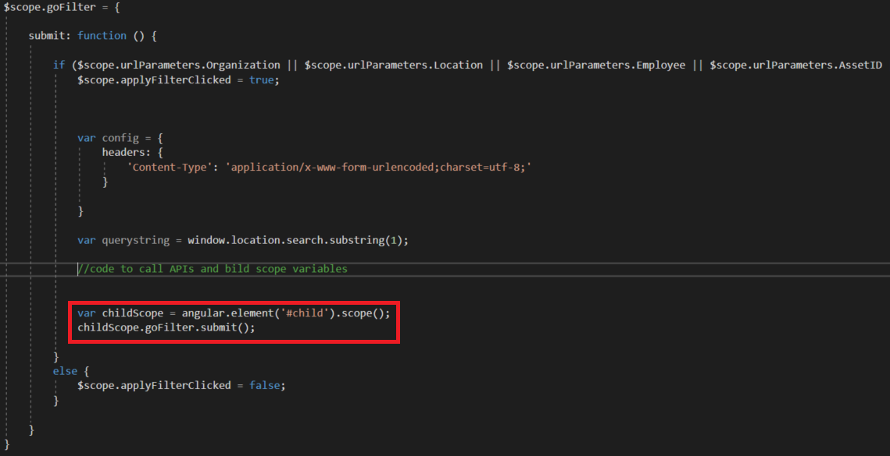

1. Handling clickable/drillable bar and other charts

